

Name : Jaijitesh Suryaprakash
Reg No : 25BIT0235
Assessment – 8
Review – 1

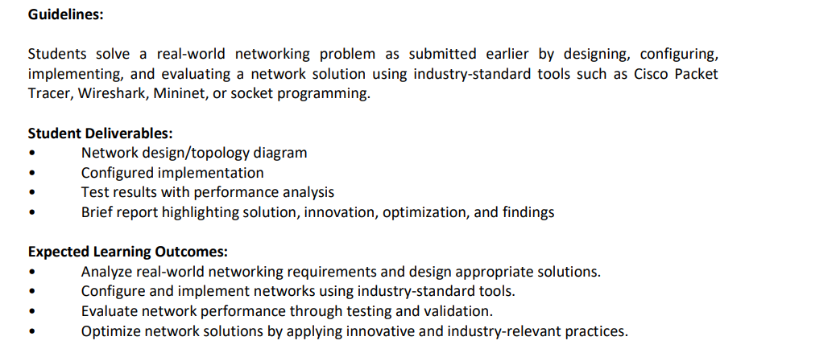

Problem Analysis :
Modern enterprise campuses have departments. Each department has needs for security and network speed. In a Layer 2 network everything is connected on the same level. This creates problems such as
Security and Confidentiality Risk:
Sensitive data like payroll records from HR and accounting ledgers from Finance are on the network as experimental software from R&D and production machines on the shop floor. They all share the broadcast domain. This means anyone connected can easily capture data packets. It makes packet sniffing simple. It also allows movement across the network, which is a big security risk.

Network Performance Degradation:
Broadcast traffic such as ARP requests DHCP discovery messages and NetBIOS traffic spreads to every port. This flood of data uses up bandwidth. Slows down the network. It also forces devices to spend more CPU time processing traffic they don’t need. Performance drops across the network.

Blast Radius:
If one department has a problem. Like a malware infection a rogue DHCP server or a broadcast loop. The issue spreads fast. The entire facility can be affected. Operations, in departments can stop because the problem is not isolated.

Solution:
Use network segmentation. This can be done using IEEE 802.1Q Virtual Local Area Networks (VLANs). On a Cisco Catalyst 2960 switch VLANs allow departments to be separated into their virtual networks. This keeps data secure reduces broadcast traffic and limits the impact of errors or attacks. Each department gets its isolated broadcast domain. Security improves. Performance stays high.. The blast radius shrinks.

Network Topology & Addressing Architecture :
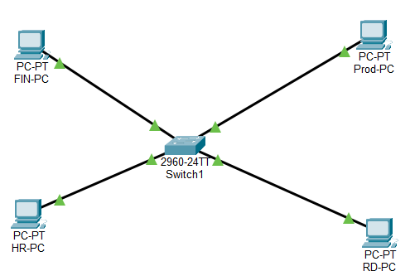

IP & VLAN Allocation Matrix
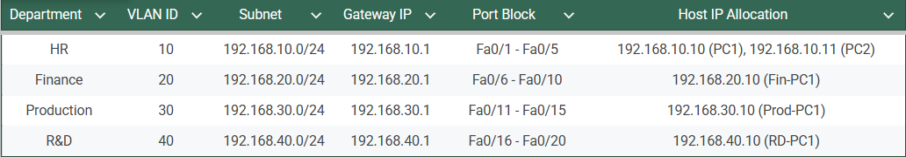

Implementation Configuration Script :
enable
configure terminal

! 1. Provision VLAN Database
vlan 10
name HR
vlan 20
name Finance
vlan 30
name Production
vlan 40
name RD
exit

! 2. Assign Port Ranges to Access VLANs
interface range fastEthernet 0/1 - 5
switchport mode access
switchport access vlan 10
exit

interface range fastEthernet 0/6 - 10
switchport mode access
switchport access vlan 20
exit

interface range fastEthernet 0/11 - 15
switchport mode access
switchport access vlan 30
exit

interface range fastEthernet 0/16 - 20
switchport mode access
switchport access vlan 40
exit

! 3. Security Hardening on Unused Ports
interface range fastEthernet 0/21 - 24, gigabitEthernet 0/1 - 2
switchport mode access
shutdown
exit

end
copy running-config startup-config

